**Womens Aid Orkney**

As lock down eases WAO will be reviewing its services daily in line with government advice.

We are currently not in the office but hope to be back soon and able to meet service users face to face.

If you require any help or need to contact your support worker, please call

**01856 877900 Mon-Fri 8.30am-4.30pm**

Outwith these times in an emergency only, please call

**07444 009 736**

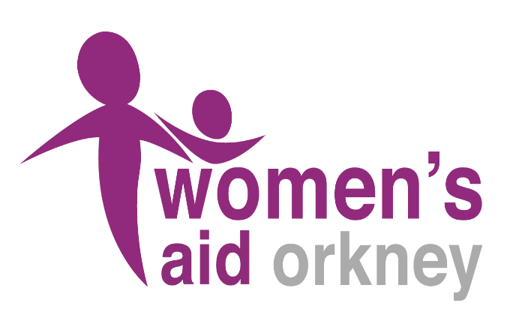 **Here for you.**